**Developer manual**

This manual depicts all the steps required by a user in order to use the social awareness website in order to successfully post concerns in the website.

**System overview**

The social awareness website is a system that enables the users to post their concerns and share views with other users in the application. The system has been implemented using Django framework for back-end implementation and React JS for the front end in order to ensure the single page functionality.

All the key functionalities of the single page application have been implemented as shown below:

1. **Register functionality.**

This is the functionality that adds new users into the system. It fetches the data entered by the user from the register form and stores it in the database after which a user is successfully registered. The following code snippets show the implementation of the functionality.

Register backend

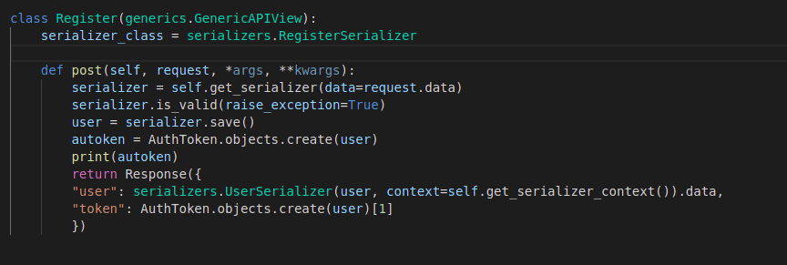

Register Front end

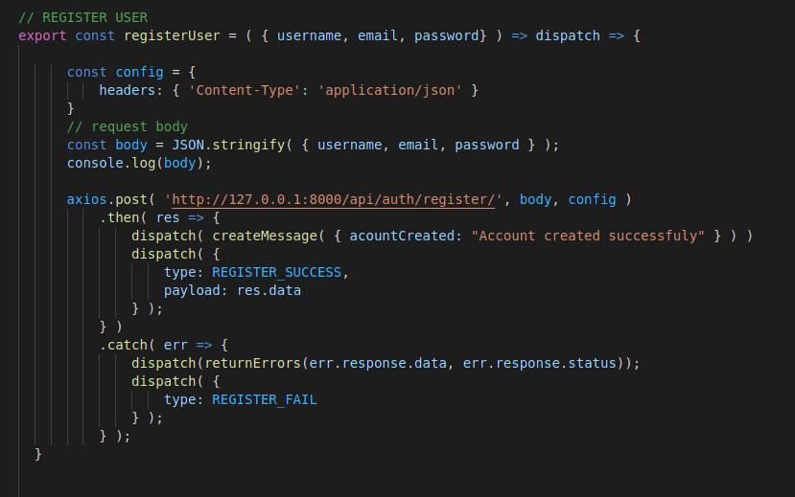

1. **Login functionality.**

This ensures that any a user can log in to the system as long as they are registered.

Login back end

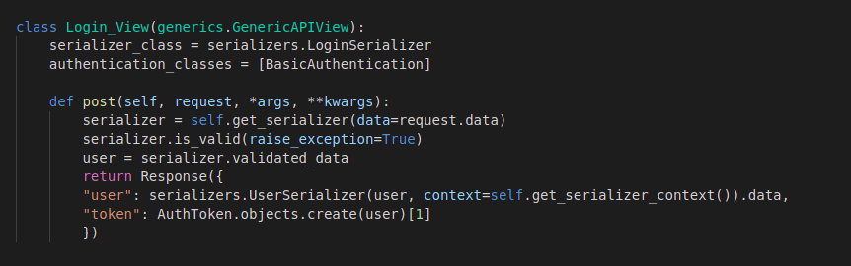

Login front end

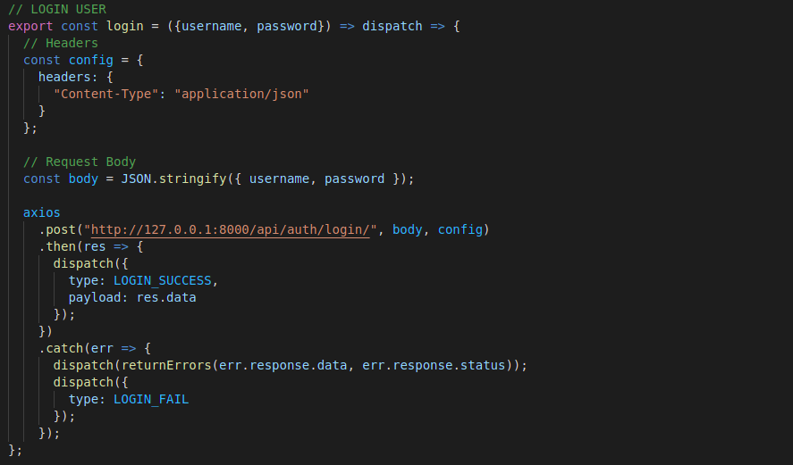

1. **Posting a campaign functionality.**

This functionality adds a new campaign into the system after a user fills in details in the add post form.

Posting campaign back end

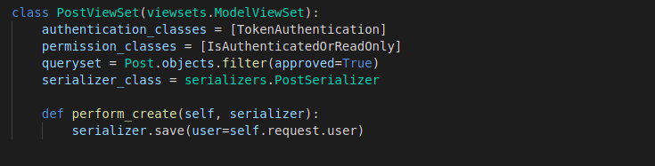

Posting campaign front end

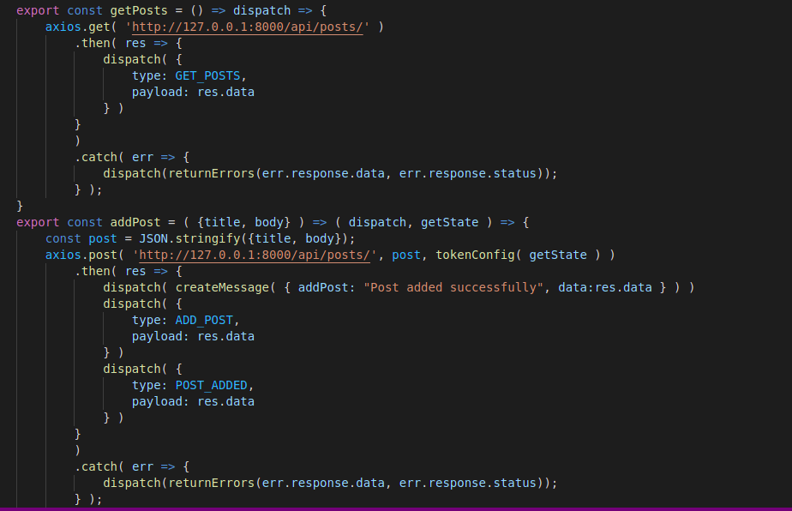

1. **Logout functionality.**

This ends the session of a logged in user

Logout back end

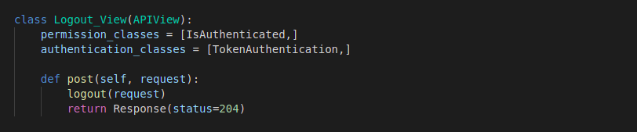

Logout front end

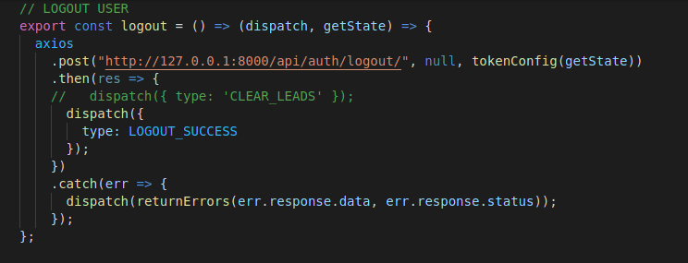

**Tools used**

The following tools were used during the development process:

* Visual studio code – this is the editor used to write the code.
* Google chrome browser – This displays the output of the code.

Its console was also used to test the working of the javascript iin the front end.

* Postman – this is used to test the working of the APIs developed in the back end.